**Name: Maria khuzema**

**Id: BIT-23F-031**

**Semester: 03**

**Section: A**

**Course: AI**

**Lab: 06**

**Lab 06**

**Task 01**:

Write a Python function that takes a number as input and returns the sum of its digits.

**Code:**

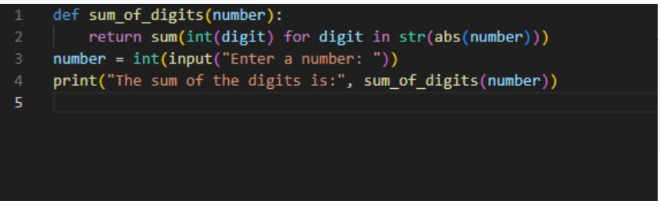

**Output:**

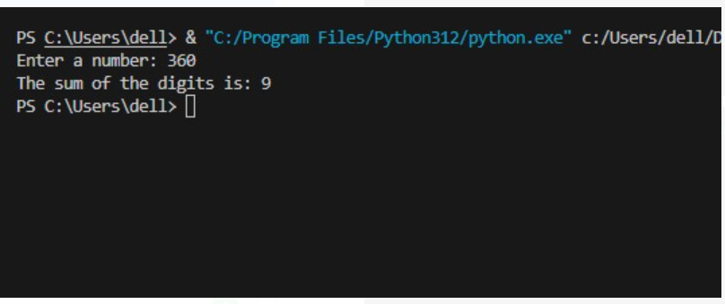

**Task: 02**

**Write a Python function that takes a sentence as input and returns the number of words in it.**

**Code:**

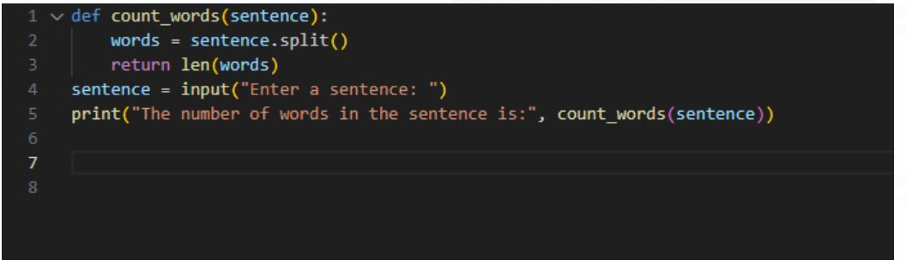

**Output:**

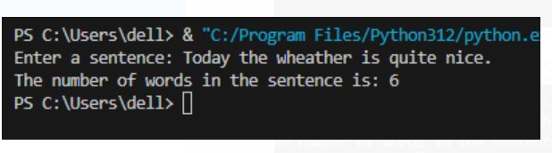

**Task: 03**

**Write a Python function that takes an integer and returns whether the number is even or odd.**

**Code:**

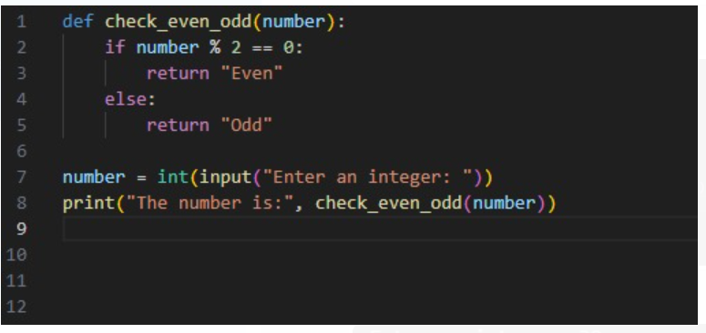

**Output:**

